**ASSIGNMENT - 13**

**PROBLEM STATEMENT -Create a workmail for your organization**.

STEP 1- Search for Amazon Work Mail & open it.

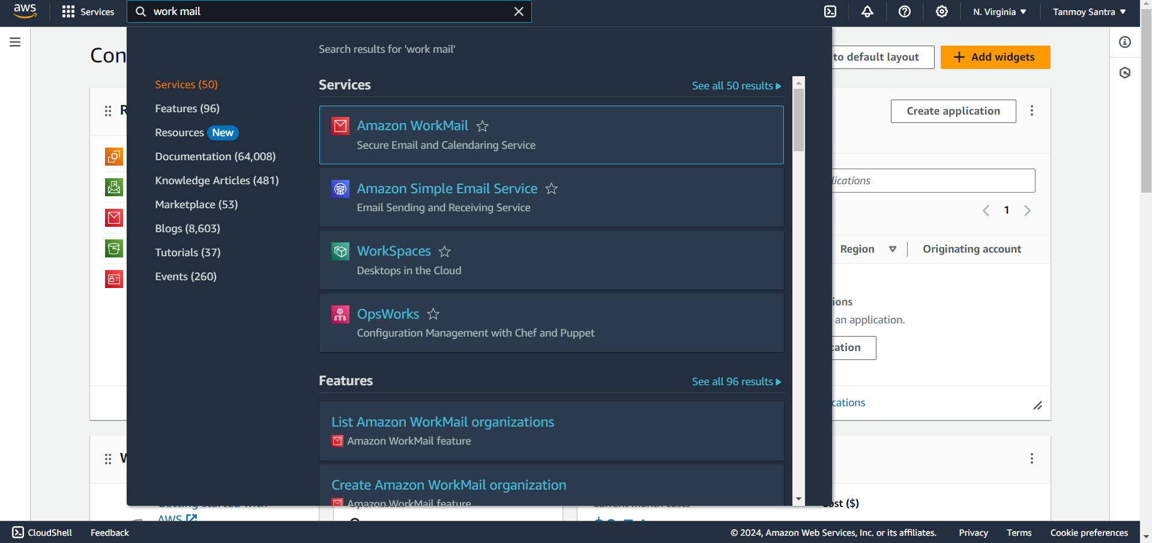

STEP 2- Click on Create Organization.

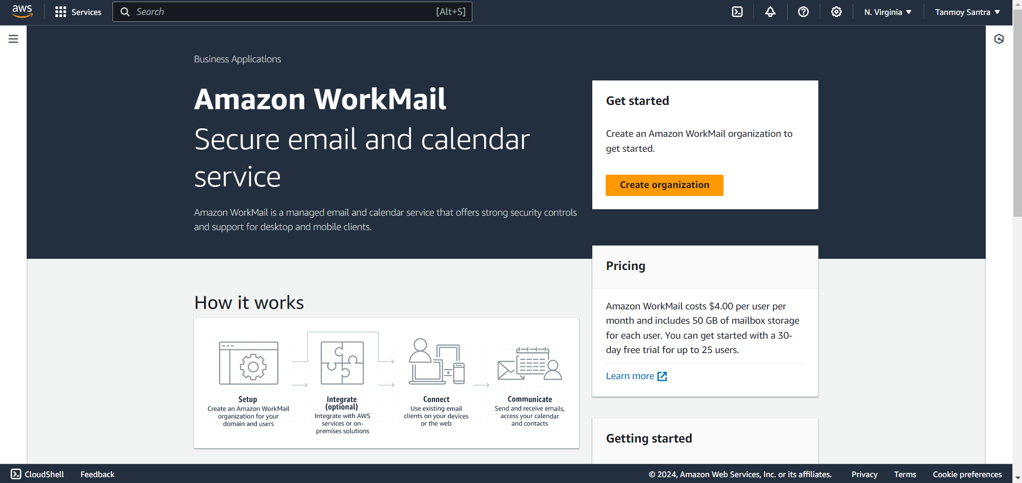

STEP 3- Select Free Test Domain. Give the organization name. Then click on Create Organization.

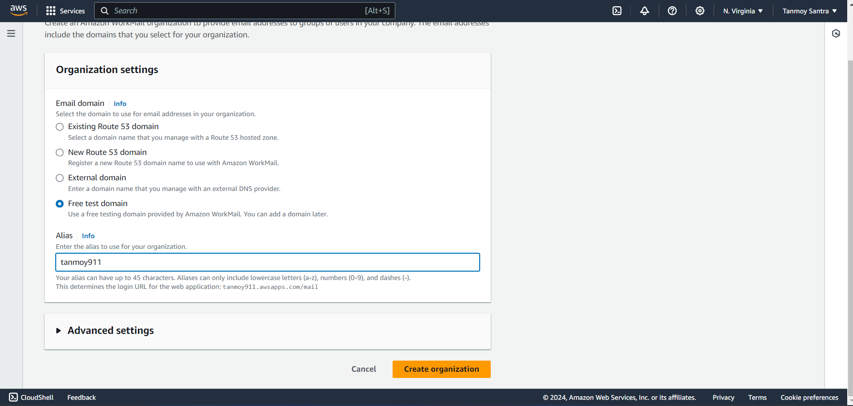

STEP 4- Click on the organization name to enter into it.

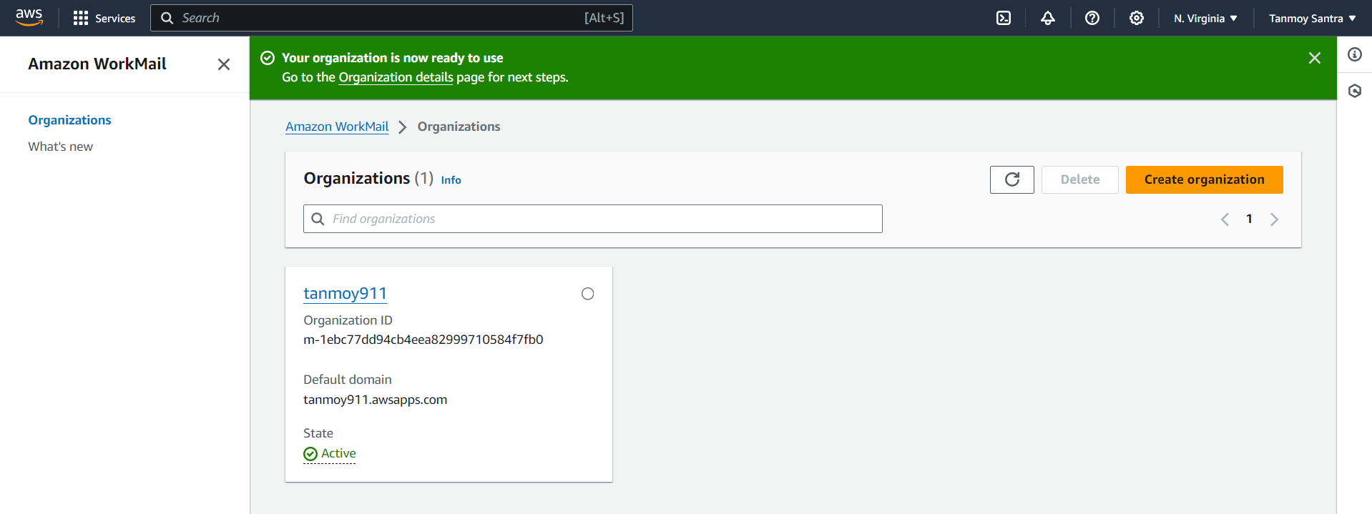

STEP 5- go to the Users option.

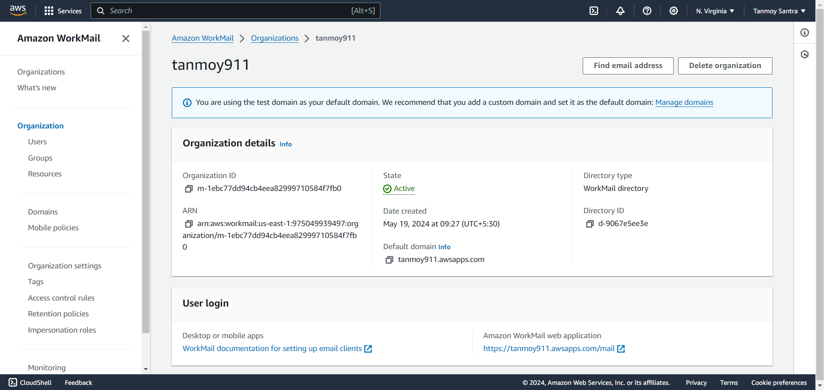

STEP 6- Click on Add User button.

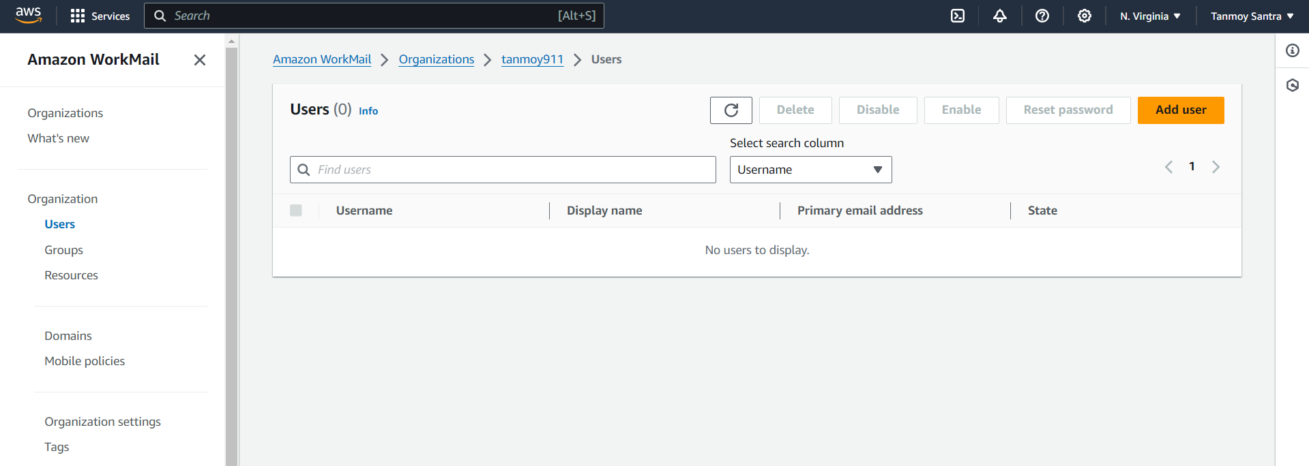

STEP 7- Fill basic user details.

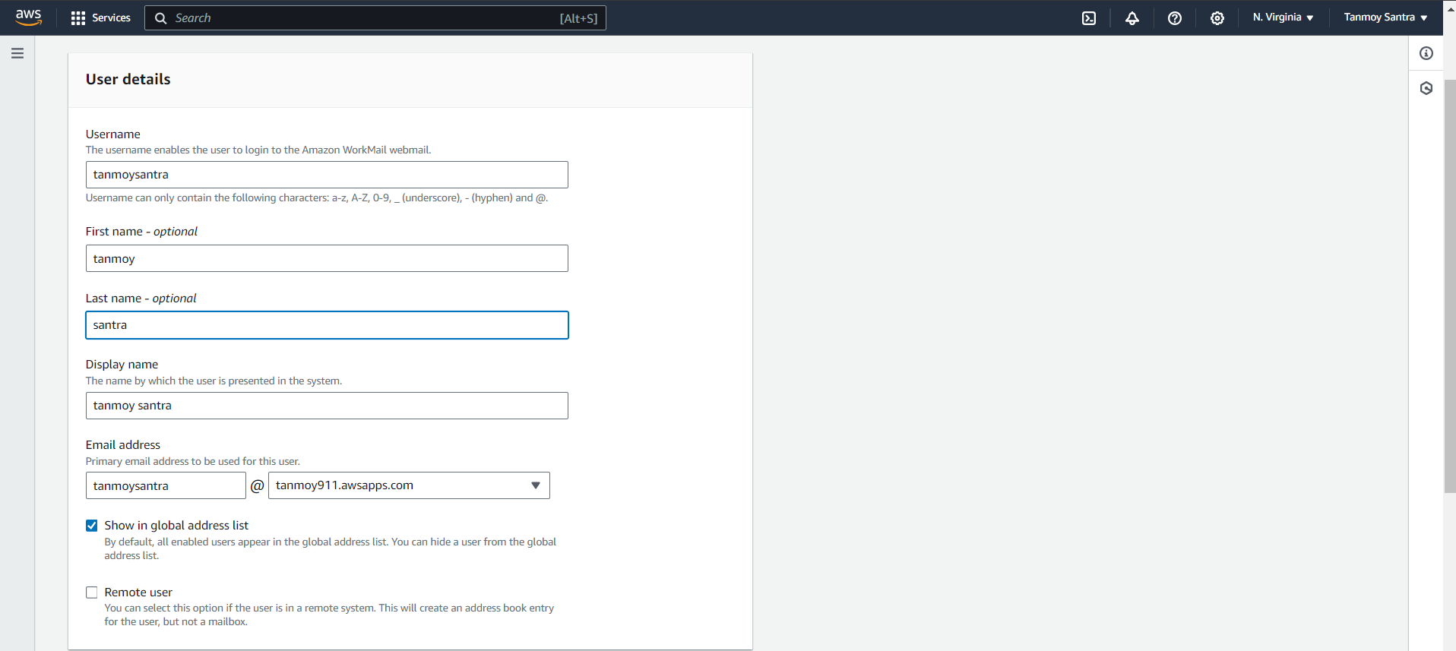

STEP 8- Set up a password. Then click on Add User.

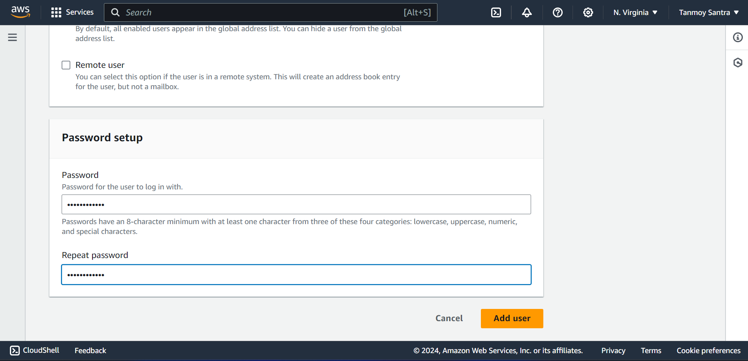

STEP 9- Now, go back & enter into Organization.

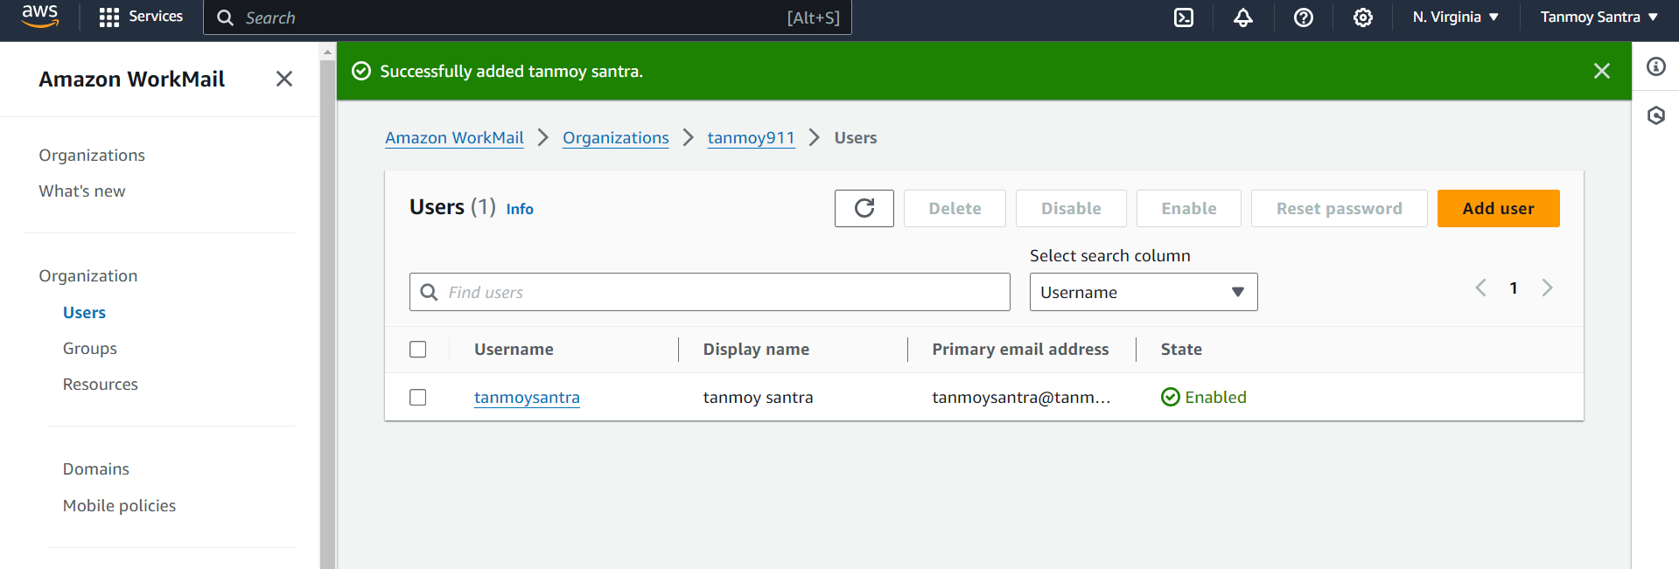

STEP 10- Click on the Amazon WorkMail Web Application link.

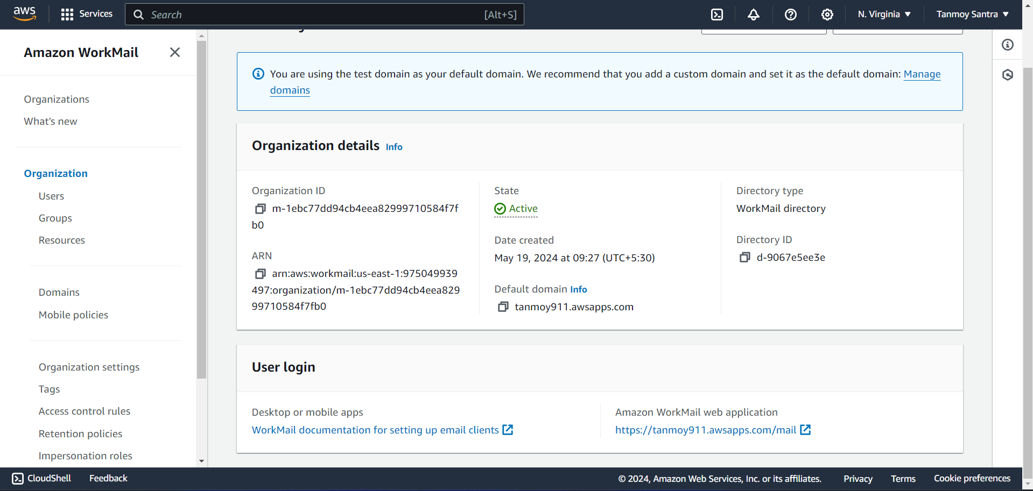

STEP 11- Login into the amazon workmail.

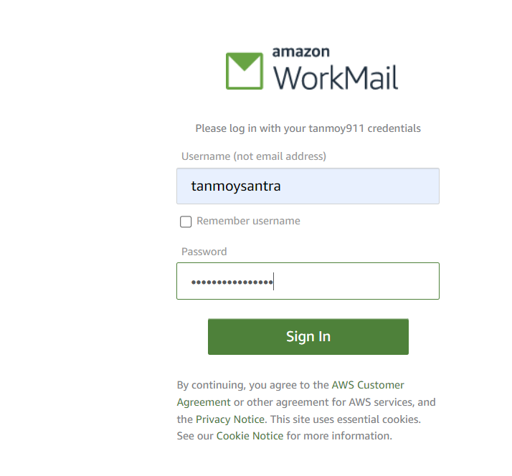

STEP 12-The inbox opens which implies that the workmail is successfully created.

